The role which creates the stage gets the privilege of “ownership” which can be transfer as well

Methodology –

1. We have created a role ankit which will create stage and hence will get the “ownership” priviledfge

#Create role

create role ankit

comment ="role to create stage"

# grant role to user the usrname is ankitlps08

grant role ankit to user ankitlps08

1. Now we need to create stage sample_internal_stge

# create stage from role Ankit

# need db to create stage

create or replace stage sample_internal_stge

comment ="test stage"

# owner shows role from which stage has been created

show stages;



*** below image is from snowflake console

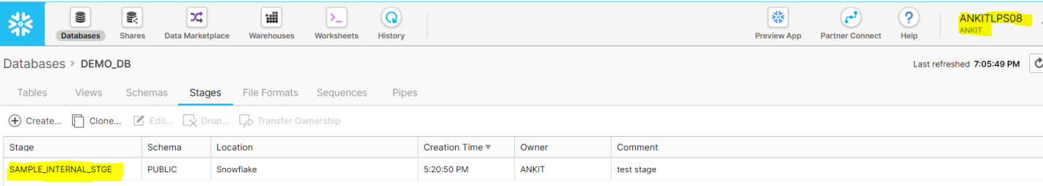

We can see that from role ankit we can see/edit the internal stage

1. Now we will create another role to read from stage

create role read_stage

comment ="role to read stage"

1. grant role read_stage to user ankitlps08

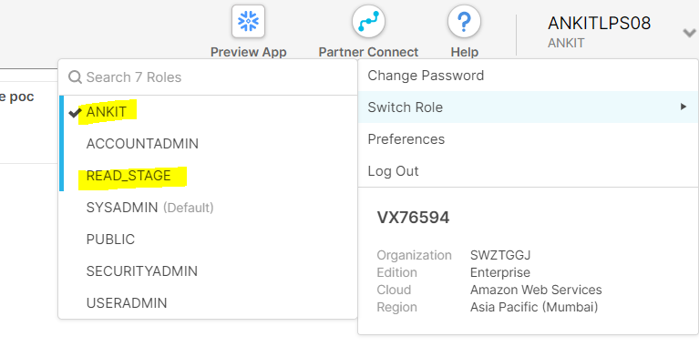

1. below screenshot shows new role read_stage doesn’t have the privilege to access sample_internal_stge

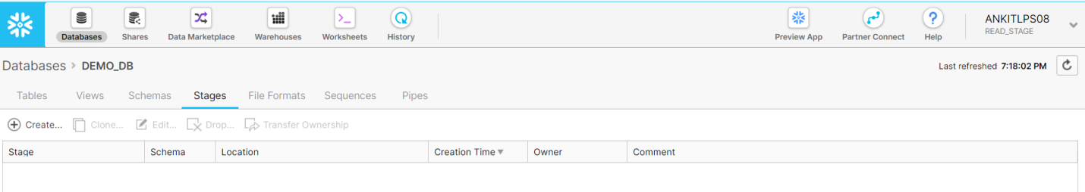

1. now we grant READ priveledge to READ_STAGE role

Grant read on STAGE sample_internal_stge to role READ_STAGE;

